MECC 2026 Special Session
Hands-On Learning with Physical and Virtual Laboratory Systems
Date: Monday, October 26, 2026
Time: 12:30–3:00 PM
Format: Lunch, presentations, and interactive rotating laboratory demonstrations

Session Agenda
Time | Activity
12:30–1:00 PM | Lunch and networking
1:00–1:10 PM | Welcoming Remarks  Dr. Ayse Tekes (Kennesaw State University)  Dr. Ahmed Mekky and Dr. Gen Sasaki (MathWorks)  Dr. Eniko Enikov (University of Arizona)
1:10–1:20 PM | MathWorks Presentation  Overview of MATLAB/Simulink tools and their integration into engineering education
1:20–2:50 PM | Interactive Laboratory Rotations  Participants rotate through four hands-on stations featuring physical experimental setups and virtual laboratories
2:50–3:00 PM | Concluding Remarks  Reflections and closing remarks from the presenters

Interactive Laboratory Stations
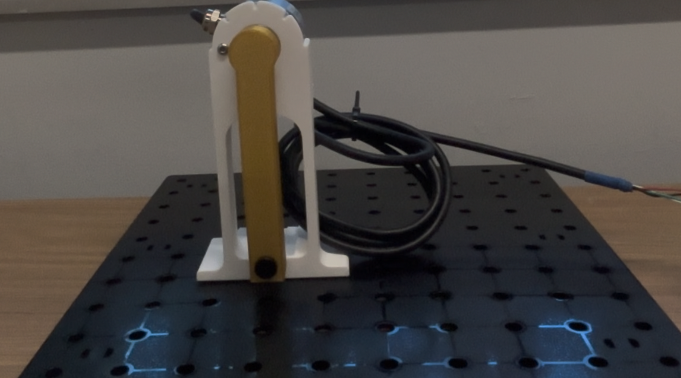 | Station 1: Single-Degree-of-Freedom (SDOF) Pendulum  Physical experiment and accompanying virtual laboratory to explore free vibration and dynamic response.
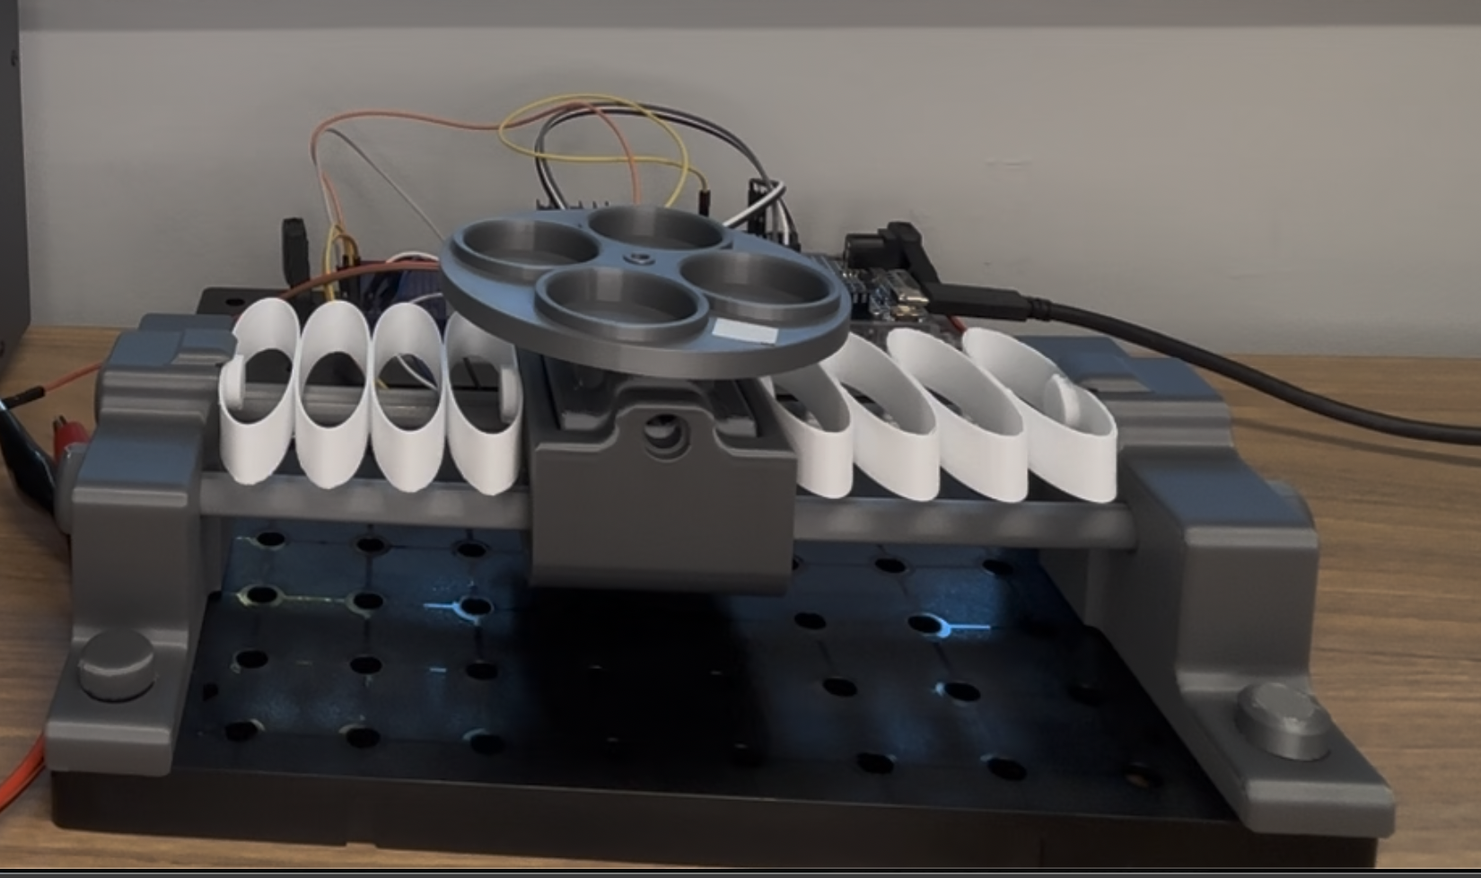 | Station 2: Rotating Unbalance System  Physical experiment and accompanying virtual laboratory to investigate forced vibration and resonance.
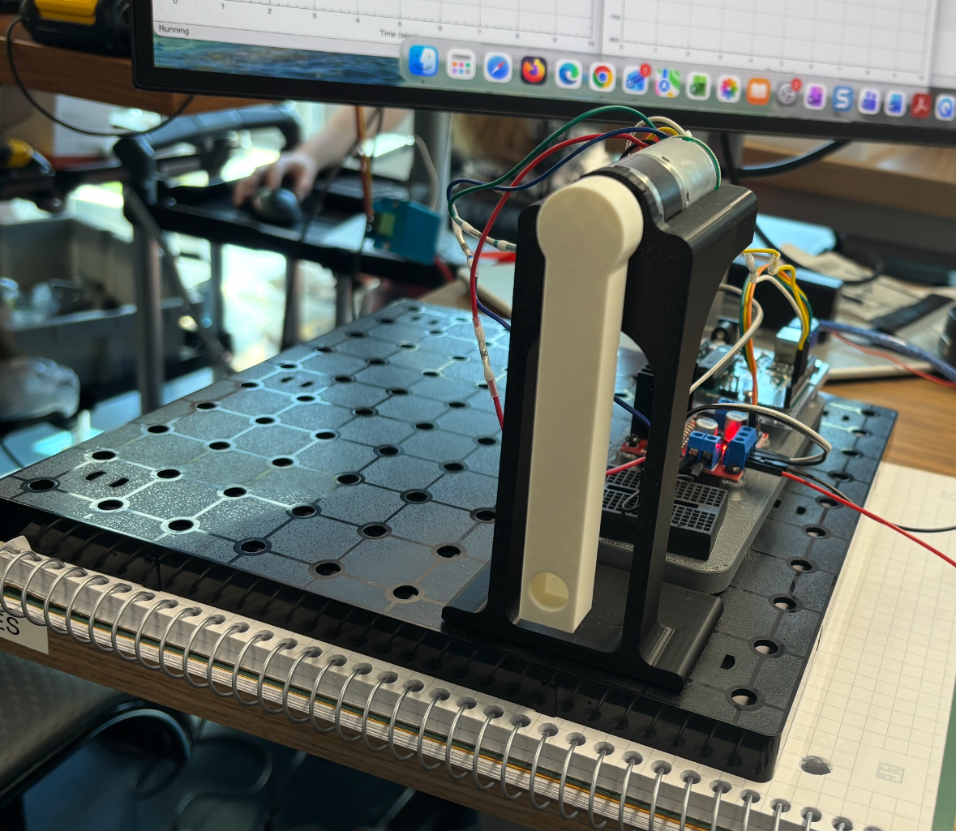 | Station 3: Controlled Pendulum  Physical experiment and accompanying virtual laboratory to demonstrate feedback control and system response.
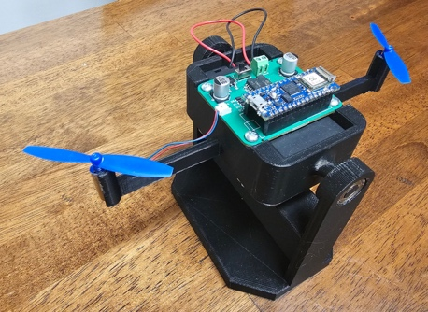 | Station 4: Bicopter System  Hands-on demonstration of a bicopter system, highlighting dynamic behavior and control.

Suggested Rotation Schedule
Participants will be divided into four groups, rotating through all four stations.
Rotation | Time | Duration
Rotation 1 | 1:20–1:40 PM | 20 minutes
Rotation 2 | 1:40–2:00 PM | 20 minutes
Rotation 3 | 2:00–2:20 PM | 20 minutes
Rotation 4 | 2:20–2:40 PM | 20 minutes
Open discussion and final questions | 2:40–2:50 PM | 10 minutes
Each 20-minute rotation includes station transitions. The first three stations integrate both physical and virtual laboratory experiences.

